Remote Control Module (RCM)

Remote Control Module (RCM) enables a master control of DMC application. Using this functionality DMC can be controlled from other software or PC via TCP/IP protocol. RCM allows loading recipe files, loading CAD files into the recipe, changing variables defined in the recipe and running recipes. For full functionality see the list of available commands.

To use DMC RCM and appropriate DMC license must be used (either as license file or USB dongle key). When DMC RCM is licensed a Remote Control section appears in DMC Settings.  
Enable remote control in File>Settings>Remote Control and set port.

For remote control to be used DMC.exe must be running either in a default or a background mode. Modes are set in File>Settings>General. Also it can be started in background mode adding “-bg” parameter to it in command line or exe file shortcut.  
Background mode starts DMC without a graphical user interface to save PC resources.

List of remote control commands for DMC RCM.

|  |  |  |  |
| --- | --- | --- | --- |
| **Command** | **Description** | **Parameters** | **Example** |
| LOAD | Loads selected recipe | File location and name | **Message:**  load “C:\Recipes\mark 123.rcp”  **Return:**  OK load “C:\Recipes\mark 123.rcp”  Error: Unable to import ‘C:\Recipes\mark 123.rcp’ file. File does not exist. |
| UNLOAD | Unload recipe | Recipe name or recipe location | **Message:**  unload “C:\Recipes\mark 123.rcp”  **Return:**  OK unload ‘C:\Recipes\mark 123.rcp’  Error: Recipe ‘C:\Recipes\mark 123.rcp’ is not found. |
| UNLOADALL | Unload all recipes |  | **Message:**  unloadall  **Return:**  OK unloadall |
| ACTIVATE | Activate one of loaded recipes | Recipe name or recipe file name | **Message:**  activate “C:\Recipes\mark 123.rcp”  **Return:**  OK activate ‘C:\Recipes\mark 123.rcp’  Error: Recipe ‘C:\Recipes\mark 123.rcp’ is not found. |
| GETACTIVE | Get file name of active recipe | - | **Message:**  getactive  **Return:**  ‘C:\Recipes\mark 123.rcp’ |
| COMPILE | Compiles current recipe.  ‘OK compile’ informs that command is accepted. Check status with STATUS command to see if compiling was successful. | - | **Message:**  compile  **Return:**  OK compile |
| STATUS | Returns status of the DMC | - | **Message:**  status  **Return:**  DISCONNECTED  CONNECTING ERROR  CONNECTED  COMPILING  COMPILING DONE  COMPILLING ERROR  RUNNING  PAUSE  PAUSED  RUNNING DONE  RUNNING ERROR  RUNNING CANCELED  HOMING  HOMING DONE JOYSTICK ACTION  JOYSTICK ACTION RUNNING  JOYSTICK ACTION DONE  WAITING |
| CONNECT | Connects to hardware. | - | **Message:**  connect  **Return:**  OK Connect  Error: Unable to connect to ‘Device’. |
| DISCONNECT | Disconnects from hardware. | - | **Message:**  disconnect  **Return:**  OK disconnect |
| RUN | Runs current recipe.  ‘OK run’ informs that command is accepted. Check status with status command to see if there are no running errors. | - | **Message:**  run  **Return:**  OK run  Error: Unable to run recipe. Not connected to hardware. |
| PAUSE | Pauses running recipe.  ‘OK pause’ informs that command is accepted. Pause will be executed only in places it is safe to resume machining (after jump motion, after machining slice, etc.).  Check status with status command to see if running is paused. | - | **Message:**  pause  **Return:**  OK pause |
| CONTINUE | Continues paused recipe. | - | **Message:**  continue  **Return:**  OK continue  Error: Unable to continue recipe. Recipe is not running. |
| CANCEL | Cancels running recipe. | - | **Message:**  cancel  **Return:**  OK cancel |
| SETVAR | Sets value of selected variable. | Variable name  Value - formula or number value | **Message:**  setvar speed 30.5 [sets variable speed to value 30.5]  setvar label “text” [sets variable label to value “text”]  **Return:**  OK setvar speed 30.5  Error: Variable ‘spe’ is not found. |
| GETVAR | Gets value of selected variable | Variable name | **Message:**  getvar speed  **Return:**  speed 30.5  Error: Variable ‘spe’ is not found. |
| SETGVAR | Sets value of selected global variable. If global variable does not exist, it will be created | Variable name  Value – text or number value | **Message:**  setgvar speed 30.5 [sets variable speed to value 30.5]  setgvar label “text” [sets variable label to value “text”]  **Return:**  OK setgvar speed 30.5 |
| GETGVAR | Gets value of selected global variable | Variable name | **Message:**  getgvar speed  **Return:**  speed 30.5  Error: Variable ‘spe’ is not found. |
| GETVARS | Gets all exported variables (access in other recipes) and values from active recipe |  | **Return format:**  Variable name \t variable value \n  **Message:**  getvars  **Return:**  speed\t123\npower\t10 |
| GETPOS | Gets position of selected axis name | Axis name: x,y,z,gx,gy,gz, axis name defined in Settings->Stages->Stage Name | **Message:**  getpos y  **Return:**  y 10.1234 |
| MARKING | Selects MARKING parameter preset for first Marking Parameters command in the recipe. | Name or MARKING parameters preset | **Message:**  marking steel_cut  **Return:**  OK marking steel_cut  Error: Preset ‘ste_cut’ not found. |
| HOME | Homes selected axis | Axis name  If no parameters are added, all axes will be homed. | **Message:**  home home X  **Return:**  OK home OK home X |
| MOVE | Moves selected axis to a set position | Axis name in DMC  Position | **Message:**  move x 10  **Return:**  Error: Axis ‘Theta’ not found. |
| LASERON | Starts laser triggering, based on current laser control settings. Similar to clicking on LASER button in Joystick. | - | **Message:**  laseron  **Return:**  OK laseron  Error: Controller doesn't support FireContinuous function. |
| LASEROFF | Stops laser triggering. | - | **Message:**  laseroff  **Return:**  OK laseroff |
| CLOSE | Closes software. | - | **Message:**  close  **Return:**  OK close |
| TRIGGER | Sends a trigger to Wait command to continue recipe |  | **Message:**  trigger  **Return:**  OK trigger |
| VIEW | Controls view | FITSCREEN  RESET | **Message:**  view fitscreen  view reset  **Return:**  OK view fitscreen  OK view reset |

Usage Example

For an example of use, we create a recipe, which marks a drawing from DXF file and a text label under it. Outgoing messages are in greed and incoming in yellow colors.

* Hardware settings must be setup correctly before using DMC in remote mode. It is best to test configuration settings and new recipes in standard DMC mode.
* A recipe for specific type of jobs has to be created. In this case, recipe contains variables for settings, cad file location and text. Save the recipe to a known location, in this case C:\recipes\LogoText.rcp  
  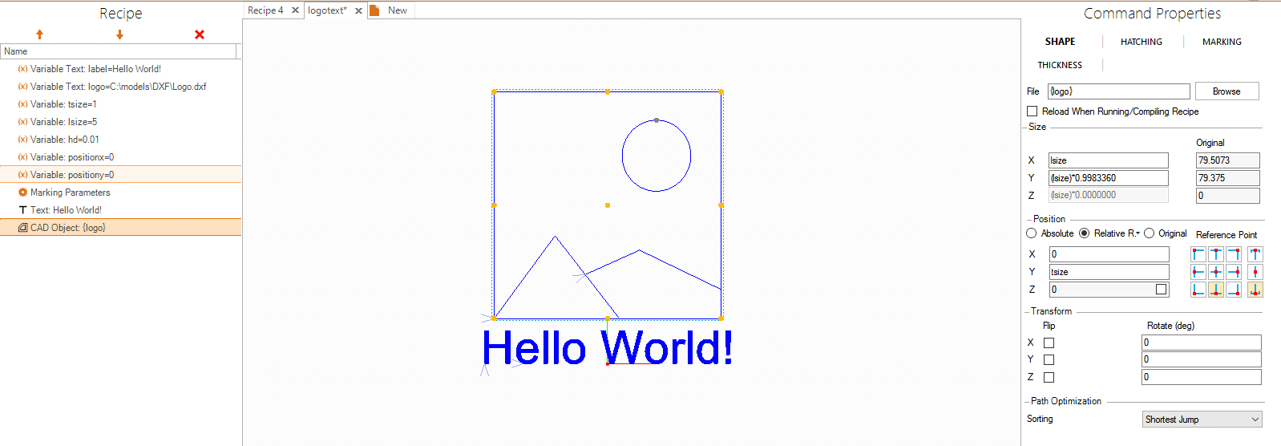
* Enable remote control and set port to use for communication with DMC in File>Settings>General ‘Remote Control’. If same PC is used default IP address is localhost (127.0.0.1) Default port is 23.
* Establish remote connection to DMC. In this example a simple Telnet communication software (PuTTY) is used. Settings for communication in this case is Connection type: Telnet, IP address: 127.0.0.1, Port 23.  
  After establishing communication DMC will provide a message with its name and version, e.g. DMC 1.2.50 RCM
* Check software status with STATUS command.  
  status  
  DISCONNECTED
* Connect to hardware and check status, to confirm that connection is done.  
  connect  
  OK connect  
  status  
  CONNECTED
* Load recipe to be used.  
  load “C:\recipes\logotext.rcp”  
  OK load “C:\recipes\logotext.rcp”
* All the variables in the recipe are set to their default (as saved by user) values. Use setvar commands to change values of variables. In this case variable is also used to define file location of the logo file. Variable logo contains text written in “”. And file location in CAD Object command is set to {logo}.  
  setvar label “Hello World!”  
  OK setvar label "Hello World!"  
  setvar logo "C:\models\DXF\Logo.dxf"  
  OK setvar logo "C:\models\DXF\Logo.dxf"  
  setvar lsize 5  
  OK setvar lsize 5  
  setvar tsize 1  
  OK setvar tsize 1  
  setvar hd 0.01  
  OK setvar hd 0.01  
  setvar positionx 0  
  OK setvar positionx 0  
  setvar positiony 0  
  OK setvar positiony 0
* Select preset for Marking Parameters command using MARKING command. If no preset is selected a preset saved in the recipe will be used. Individual parameters may be also controlled by creating variables for them in the recipe.  
  marking steel15  
  OK marking steel15
* Compile recipe to make sure everything is alright. Check the status to see if no compiling errors appeared.  
  compile  
  OK compile  
  status  
  COMPILING DONE
* Run the recipe using RUN command. Check status to see if recipe is running or finished.  
  run  
  OK run  
  status  
  RUNNING  
  status  
  RUNNING  
  status  
  RUNNING DONE
* Load next recipe, change variables or close the software using CLOSE command.